Restructuring Financial Statements
Richard P. Rumelt

In strategy work it is useful to restructure a company's financial statements to accomplish two things: (1) to focus on the long-term rather than short-term financial structure and efficiency, and (2) to generate measures which are useful in valuation. To do this it is important to have internally consistent definitions of invested capital, free cash flow, and the cost of capital. The definitions used here are consistent with those given in Valuation: Measuring and Managing the Value of Companies, by Copeland, Koller, and Murrin, second edition, John Wiley & Sons, 1994. Refer to this useful reference for details on dealing with inflation, foreign exchange, pension plans, preferred stock, minority interests, etc.

Adjusting the Income Statement to Produce NOPLAT
NOPLAT is the key earnings concept. NOPLAT (Net Operating Profit Less Adjusted Taxes) is what the after-tax operating income would be were the company unlevered. The emphasis here is on the two qualifiers operating and unlevered. To arrive at NOPLAT we adjust both EBIT (earnings before interest and taxes) and Taxes. EBIT is not a technically defined term and is often not directly reported. Even when reported, it often includes interest income and amortization expense, which we wish to exclude. On most income statements, EBIT will be labeled Operating Income. In any event, our intention is to include operating income, but not interest income, and to avoid deducting interest, lease, and amortization expenses. Note that EBIT does include depreciation expense. To adjust the EBIT figure normally provided we must
- Add back to EBIT any amortization of goodwill expense that may be included in it. This is a non-cash non-deductable expense. It distorts the income available to investors.
- Subtract from EBIT any interest income. Interest income is non-operating income.
- Add back to EBIT any lease expenses that may be included in it. Lease expenses are like interest and should not be included in EBIT.
Next we must adjust the "Provision for Income Taxes" figure for these adjustments and for non-operating issues. The Cash Taxes on EBIT are computed by starting with the reported provision for taxes adjusting as follows:
- Subtract the portion of the tax provision that is deferred. Sometimes this amount is explicitly stated; other times one must look at the increase in deferred tax liability. The "Deferred Taxes" liability account accumulates the difference between cash taxes paid and taxes reported on the income statement. This difference normally arises because the company uses straight-line depreciation for reporting and accelerated depreciation for tax purposes. The increase in this liability in any year is the degree to which the income statement overstates the actual cash taxes paid. Hence we add this increase to net income to undo this distortion. Sometimes it is necessary to combine both long and short-term deferred-tax accounts, and less frequently it is necessary to net deferred-tax liability accounts against deferred-tax asset accounts. Sometimes the effects of acquisitions render the increase in deferred tax liability meaningless for correcting taxes to a cash basis..
- Since we have taken out interest expense, we must adjust the taxes to what they would have been without interest expense deductions. Add the tax shield on interest expense ( T×IntExp). Here, T is the marginal corporate income tax rate.
Exhibit 1—Geneeral Mills Statement of Income
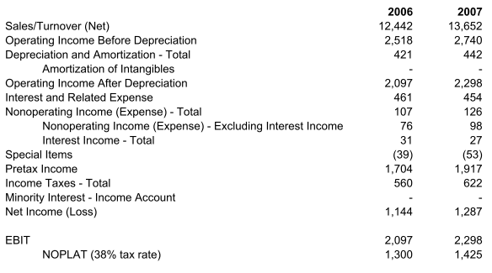
- Similarly, since lease payments have been taken out of EBIT. we must also adjust taxes to what they would have been without them. Add the tax shield on lease expenses.
- Subtract the taxes on interest income (to match the elimination of interest income from EBIT).
- Subtract taxes on non-operating (non-recurring) income (i.e., income from discontinued operations, unrelated subsidiaries, capital gains on sales, foreign-exchange gains). We wish to concentrate on operations and not count non-recurring non-operating income. If there are predictable recurring income items in non-operating income, they should probably be added to EBIT, in which case you should not adjust the tax provision for that amount.
To illustrate the computation of NOPLAT, consider the 2006-2007 income statement of General Mills (Error! Reference source not found.). There EBIT is labeled “Operating Income after Depreciation,” so we simply compute NOPLAT as EBIT*(1-T).

Adjusting the Balance Sheet to Produce Invested Capital
The balance sheet adjustments are as follows:
- Subtract excess cash and/or marketable securities from current assets and from equity. The resulting current asset account is named adjusted current assets. Most companies require between 0.5% and 2% of sales in cash and/or marketable securities to support operations, each industry having its own norms. When much more than this amount is held, it should be removed from the balance sheet as it is not a "structural" policy and is not supporting business operations.
- Look at subtracting goodwill from the appropriate asset account and from equity. Goodwill arises when firms pay more for acquisitions than book value. It is of-ten useful to work with invested capital numbers based on eliminating goodwill, and alternate figures without this elimination.
- Move net deferred tax liabilities into the equity account.
- Move any interest-bearing debt (or capitalized leases) out of current assets and add to the long-term debt account. The remaining adjusted current liabilities are all non-interest bearing.
- Net adjusted current liabilities against adjusted current assets to produce adjusted working capital.
- Net the remaining Other Liabilities against the remaining Other Assets to give Net Other Assets.
- Capitalize any operating leases that have not been capitalized and add to both assets and liabilities.

To illustrate these balance sheet adjustments, again consider the 2006-2007 financial statements of General Mills.
Excess cash was estimated as cash held over 3% of revenues. The company’s balance sheet showed an item for capitalized lease obligations ($23 and $20 million for 2006-07), but notes also showed non-capitalized lease obligations of $242 and $296 over the next five years. The capital value of these leases was estimated as 7*(L/5), where L is the reported 5-year obligation. The multiplier of 7 is the ratio of value to annual lease payments for a 10-year 7% lease.
The consequences of all these adjustments are a much simplified balance sheet shown in Exhibit XX. Stockholders’ equity has almost disappeared—the consequence of removing the huge goodwill account. Given this data, we can compute ROIC as ROIC = NOPLAT / Average Invested Capital = 1425/7916 = 18%. a very healthy number. On the other hand, if we put goodwill back into our balance sheet, average “invested” capital rises to $14,727 million and ROIC falls to 9.7%.

Computing EVA
The popular EVA metric is easily computed from these figures. By definition,
EVA = NOPLAT – WACC*InvestedCapital.

The idea is to deduct from NOPLAT a charge for the capital invested into the firm. If we assume that General Mill’s WACC was 8% in 2007, this gives
EVA = 1425 - 0.08*7916 = $792 (excluding goodwill)
and
EVA = 1425 - 0.08*14727 = $247 (including goodwill).

Leaving out goodwill omits the fact that shareholders have “invested” in high payments for acquired companies. Counting goodwill in invested capital mixes apples and oranges. It marks up the value of assets acquired via recent acquisition, but does not mark up the company’s original investments

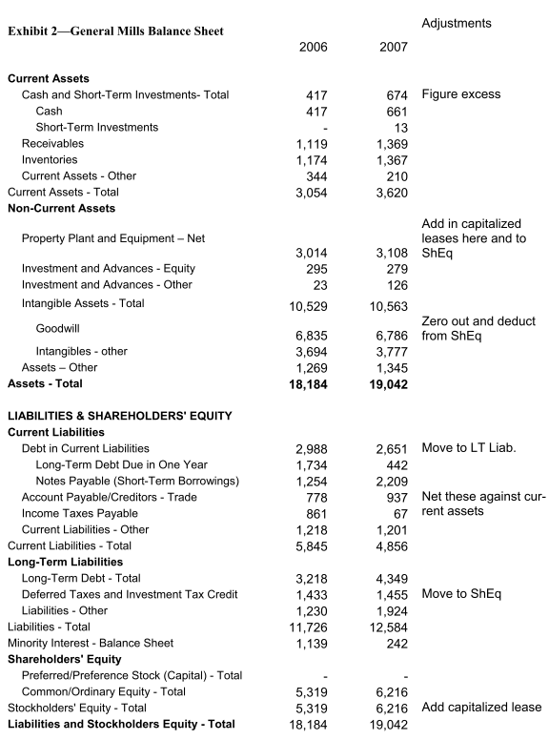
.

Exhibit 2—Geneeral Mills Statement of Income
